Screenshot for Application:

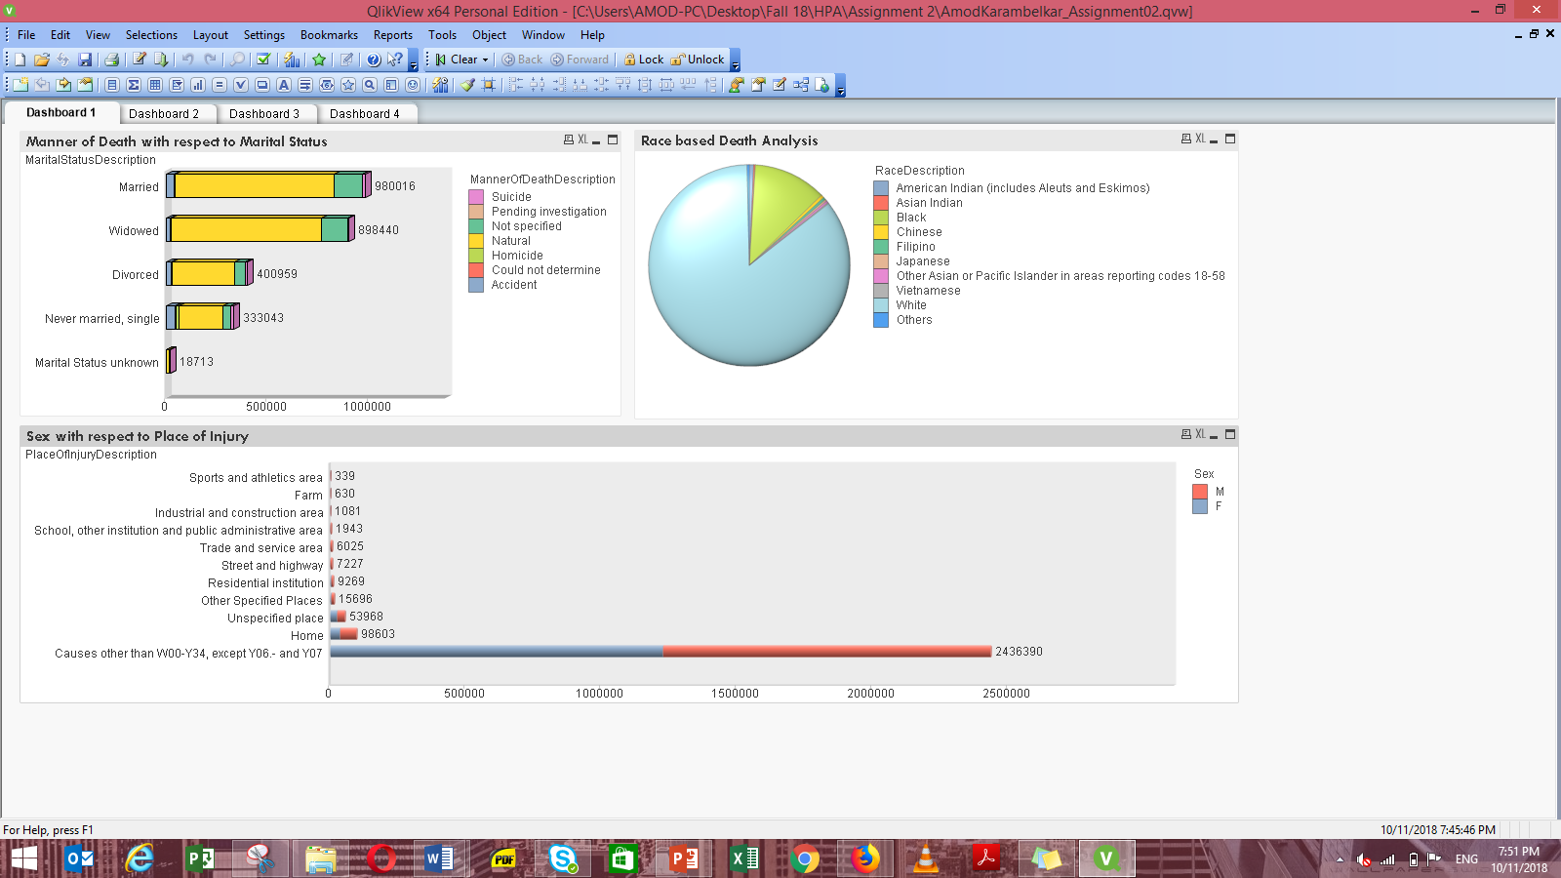

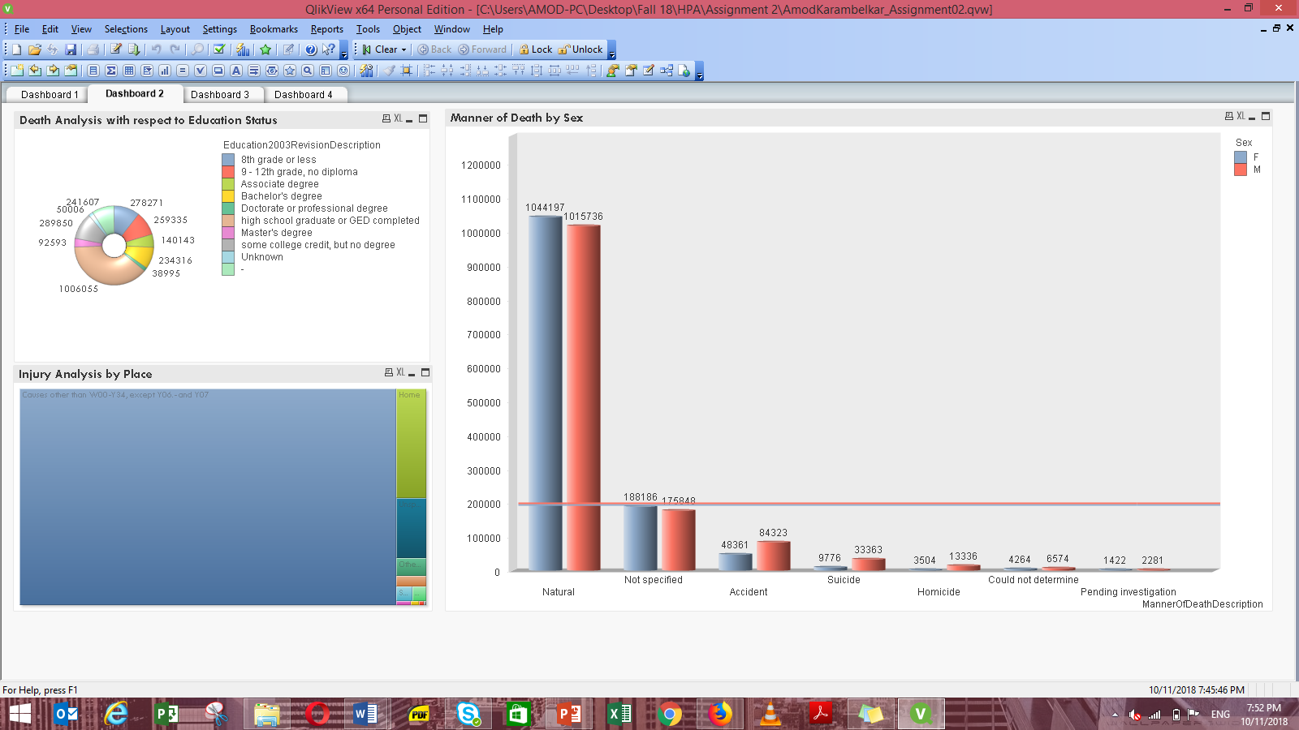

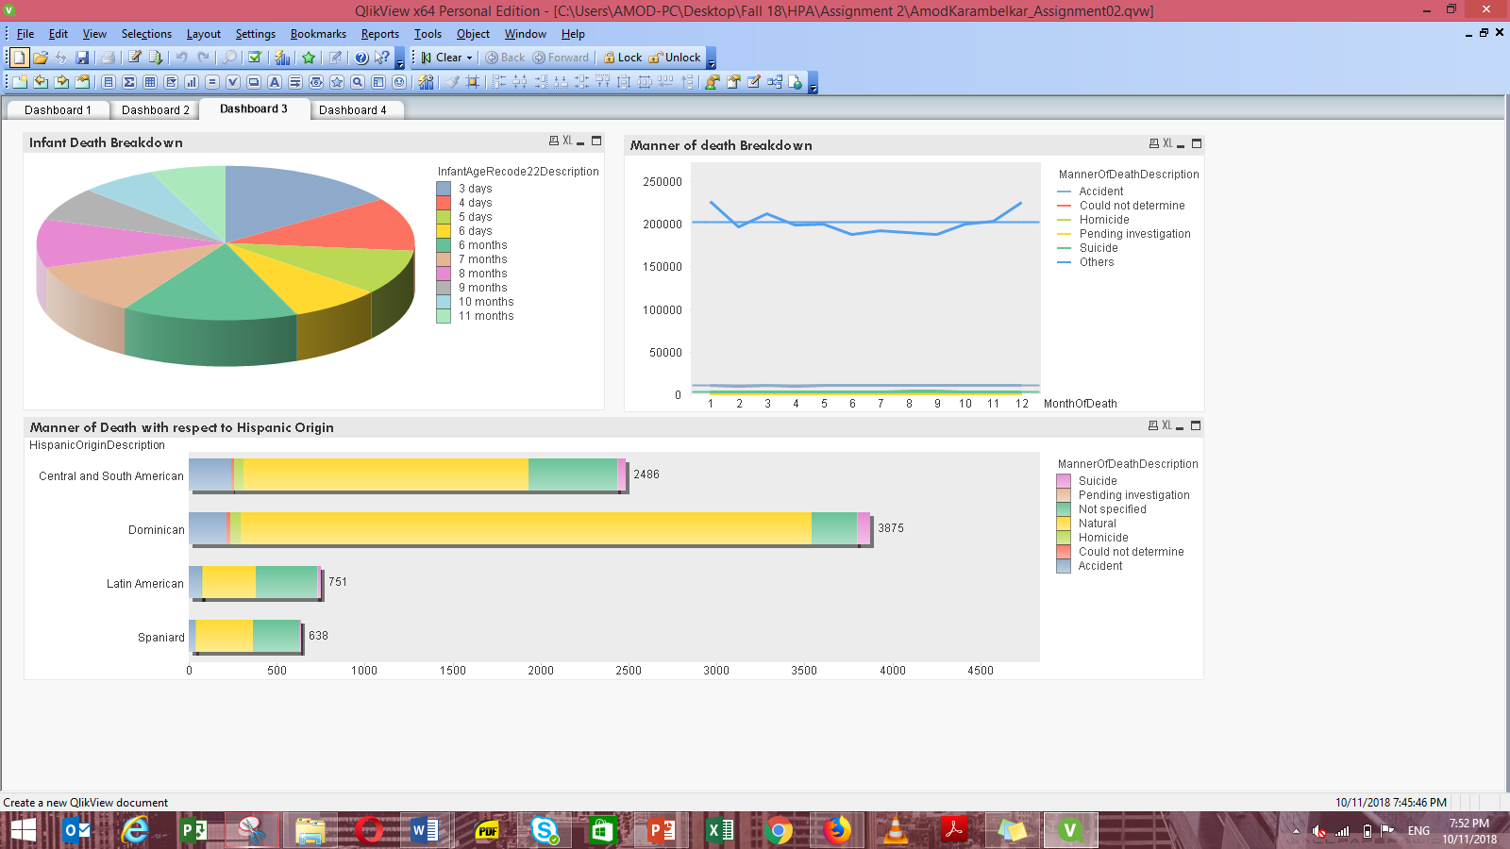

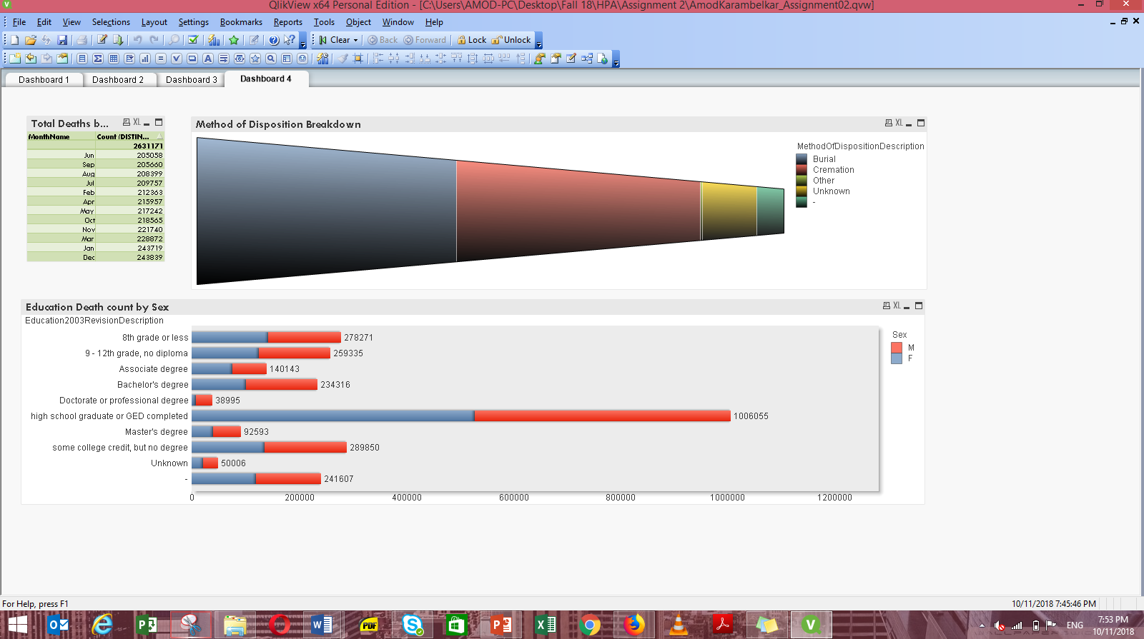

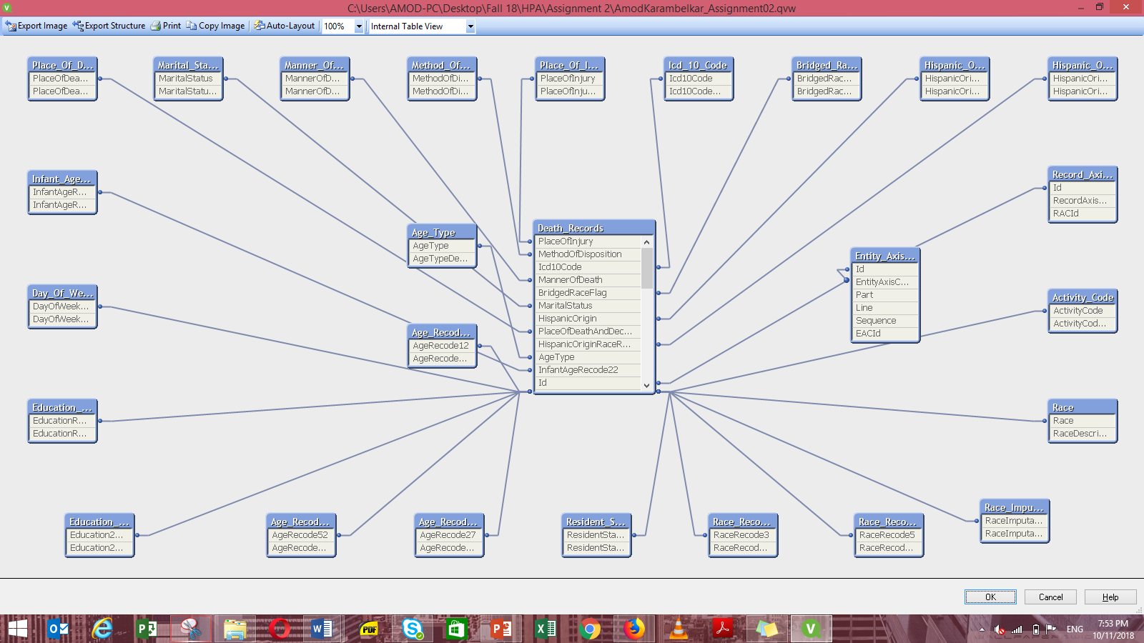

Script:

Activity_Code:  
**LOAD** Code as ActivityCode,  
 Description as ActivityCode_Description;  
**SQL** SELECT *  
FROM ActivityCode;  
  
Race:  
**LOAD** Code as Race,  
 Description as RaceDescription;  
**SQL** SELECT *  
FROM Race;  
  
Race_Imputation_Flag:  
**LOAD** Code as RaceImputationFlag,  
 Description as RaceImputationFlagDescription;  
**SQL** SELECT *  
FROM RaceImputationFlag;  
  
Race_Recode_5:  
**LOAD** Code as RaceRecode5,  
 Description as RaceRecode5Description;  
**SQL** SELECT *  
FROM RaceRecode5;  
  
Race_Recode_3:  
**LOAD** Code as RaceRecode3,  
 Description as RaceRecode3description;  
**SQL** SELECT *  
FROM RaceRecode3;  
  
Resident_Status:  
**LOAD** Code as ResidentStatus,  
 Description as ResidentStatusDescription;  
**SQL** SELECT *  
FROM ResidentStatus;  
  
  
Entity_Axis_Conditions:  
**LOAD** Id as EntityAxisConditionsId,  
 DeathRecordId as Id,  
 Part,  
 Line,  
 Sequence,  
 Icd10Code as EACId;  
**SQL** SELECT *  
FROM EntityAxisConditions;  
  
Record_Axis_Conditions:  
**LOAD** Id as RecordAxisConditionsId,  
 DeathRecordId as Id,  
 Icd10Code as RACId;  
**SQL** SELECT *  
FROM RecordAxisConditions;  
  
Age_Recode_27:  
**LOAD** Code as AgeRecode27,  
 Description as AgeRecode27Description;  
**SQL** SELECT *  
FROM AgeRecode27;  
  
Age_Recode_52:  
**LOAD** Code as AgeRecode52,  
 Description as AgeRecode52Description;  
**SQL** SELECT *  
FROM AgeRecode52;  
  
Age_Recode_12:  
**LOAD** Code as AgeRecode12,  
 Description as AgeRecode12Description;  
**SQL** SELECT *  
FROM AgeRecode12;  
  
  
Age_Type:  
**LOAD** Code as AgeType,  
 Description as AgeTypeDescription;  
**SQL** SELECT *  
FROM AgeType;  
  
Death_Records:  
**LOAD** Id,  
 ResidentStatus,  
 Education1989Revision,  
 Education2003Revision,  
 EducationReportingFlag,  
 MonthOfDeath,  
 Sex,  
 DayOfWeekOfDeath,  
 CurrentDataYear,  
 AgeType,  
 Age,  
 AgeSubstitutionFlag,  
 AgeRecode52,  
 AgeRecode27,  
 AgeRecode12,  
 InfantAgeRecode22,  
 PlaceOfDeathAndDecedentsStatus,  
 MaritalStatus,  
 InjuryAtWork,  
 MannerOfDeath,  
 MethodOfDisposition ,  
 Autopsy,  
 ActivityCode,  
 PlaceOfInjury,  
 Icd10Code,  
 CauseRecode358,  
 CauseRecode113,  
 InfantCauseRecode130,  
 CauseRecode39,  
 NumberOfEntityAxisConditions,  
 NumberOfRecordAxisConditions,  
 Race,  
 BridgedRaceFlag,  
 RaceImputationFlag,  
 RaceRecode3,  
 RaceRecode5,  
 HispanicOrigin,  
 HispanicOriginRaceRecode,  
 Month(MakeDate(2014,MonthOfDeath)) as MonthName;  
**SQL** SELECT *  
FROM DeathRecords;  
  
  
Bridged_Race_Flag:  
**LOAD** Code as BridgedRaceFlag,  
 Description as BridgedRaceFlagDescription;  
**SQL** SELECT *  
FROM BridgedRaceFlag;  
  
Day_Of_Week_Of_Death:  
**LOAD** Code as DayOfWeekOfDeath,  
 Description as DayOfWeekOfDeathDescription;  
**SQL** SELECT *  
FROM DayOfWeekOfDeath;  
  
Education_2003_Revision:  
**LOAD** Code as Education2003Revision,  
 Description as Education2003RevisionDescription;  
**SQL** SELECT *  
FROM Education2003Revision;  
  
Education_Reporting_Flag:  
**LOAD** Code as EducationReportingFlag,  
 Description as EducationReportingFlagDescription;  
**SQL** SELECT *  
FROM EducationReportingFlag;  
  
Hispanic_Origin:  
**LOAD** Code as HispanicOrigin,  
 Description as HispanicOriginDescription;  
**SQL** SELECT *  
FROM HispanicOrigin;  
  
Hispanic_Origin_Race_Recode:  
**LOAD** Code as HispanicOriginRaceRecode,  
 Description as HispanicOriginRaceRecodeDescription;  
**SQL** SELECT *  
FROM HispanicOriginRaceRecode;  
  
Icd_10_Code:  
**LOAD** Code as Icd10Code,  
 Description as Icd10CodeDescription;  
**SQL** SELECT *  
FROM Icd10Code;  
  
Infant_Age_Recode_22:  
**LOAD** Code as InfantAgeRecode22,  
 Description as InfantAgeRecode22Description;  
**SQL** SELECT *  
FROM InfantAgeRecode22;  
  
Manner_Of_Death:  
**LOAD** Code as MannerOfDeath,  
 Description as MannerOfDeathDescription;  
**SQL** SELECT *  
FROM MannerOfDeath;  
  
Marital_Status:  
**LOAD** Code as MaritalStatus,  
 Description as MaritalStatusDescription;  
**SQL** SELECT *  
FROM MaritalStatus;  
  
Method_Of_Disposition:  
**LOAD** Code as MethodOfDisposition,  
 Description as MethodOfDispositionDescription;  
**SQL** SELECT *  
FROM MethodOfDisposition;  
  
Place_Of_Death_And_Decedent_Status:  
**LOAD** Code as PlaceOfDeathAndDecedentsStatus,  
 Description as PlaceOfDeathAndDecedentsStatusDescription;  
**SQL** SELECT *  
FROM PlaceOfDeathAndDecedentsStatus;  
  
Place_Of_Injury:  
**LOAD** Code as PlaceOfInjury,  
 Description as PlaceOfInjuryDescription;  
**SQL** SELECT *  
FROM PlaceOfInjury;